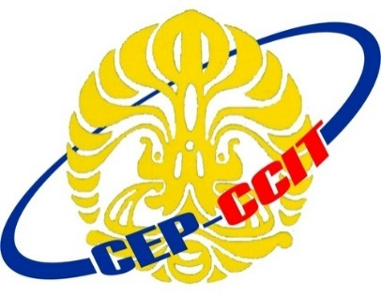

ContinuingEducationProgram

Center for Computing and Information Technology

Faculty of Engineering

University of Indonesia

**ISAS ( Information Search and Analysis Skill)**

**“Digital Watermarking”**

Group 2

Muhamad Hudya Ramadhana

Mutia Ayu Dianita

Faculty :

Fachran Nazarullah S.Kom

Class : 4SC1

Faculty of Engineering University of Indonesia

Depok 16424